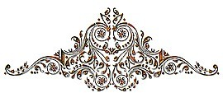
Baby Dedication

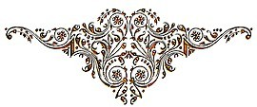

This is to certify that

“Let the children come to me; do not hinder them, for to such belongs the kingdom of God.”

Mark 10:14

was publicly dedicated to the Lord on the day of in the year of our Lord
at

Parents

Pastor

