Next Week @ TNT Kids Church…
It’s a Dilly of a Sunday!
Pickle pops and jumbo pickle snacks!

Visit us on Facebook for the latest news!
www.facebook.com/mendingbrokenpeople

People I Want to Bring Next Sunday:

My Weekly Scripture:

“Your heart will be where you treasure is.” Luke 12:34 (NIV)

Kids Church
Teaching and Training That Rocks!
TNT

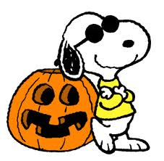
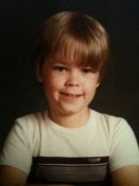
Meet the Kid of the Week: Chris Patrick
Event Alert! Fall Festival is coming up. Looking for playful grown ups who don’t mind getting dunked, stuffing goodie bags or setting up festival games. Talk to Monica or Sandra for more information!
Chris loves kids’ church and bringing his friends to church too. Last week, Chris won our attendance contest, by bringing 7 new friends to TNT!

Congratulations Chris and keep up the good work. We are proud of you!

Big Big TNT Thank You’s to last month’s volunteers:
Kim Chapman: Yum. We love your sweet treats!
Karla Johnson: Great game ideas. Thank you!
Bud Johnson: The kids loved your lesson on David and Goliath.
Jesse McAlary: Our kids are still singing that song you wrote. Thanks for bringing your guitar ministry to our children’s church!

Hi Mom, Dad and Grandparents!
Many of you asked what we needed this fall. We need candy for the upcoming fall festival, juice boxes and snacks for our snack bar. We could also use new Bible coloring books and a new stock of Crayons and pencils. Please leave your donations at the reception desk of children’s church!

