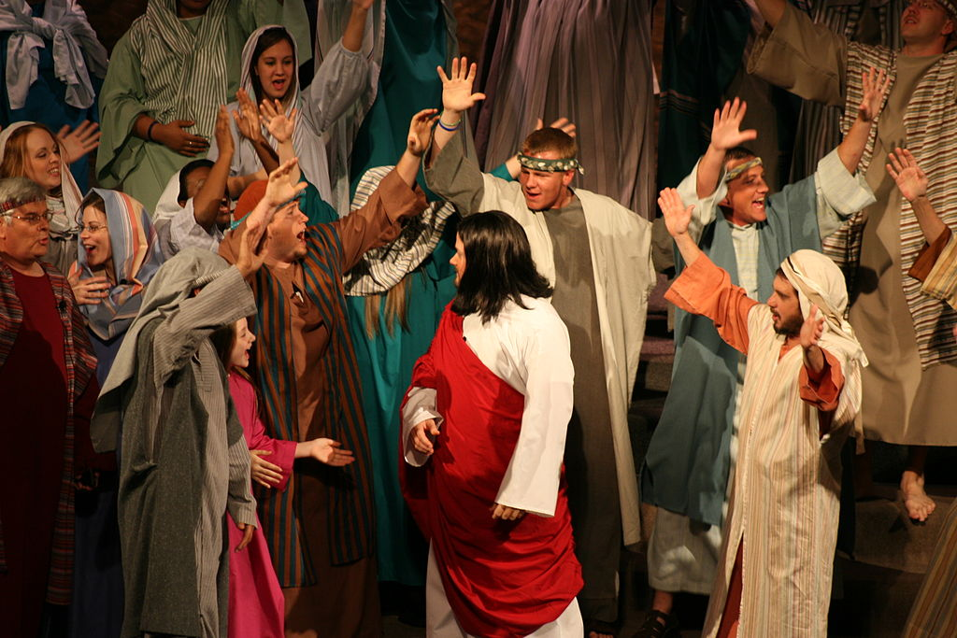
Simple Easter Play Script
By Felicia Mollohan
Setting: Amy & Derrick are playing in their house talking excitedly about Easter tomorrow. They are talking about the material parts of Easter: eggs, bunnies, baskets, candy, egg hunts, etc. Mindy overhears their conversation and steps in to tell them the true story of Easter. The scene will break away for parts of the pictures in order to see the story come to life.
Amy, Derrick, and Mindy are on the right front side of the stage, possibly on the stairs. Amy and Derrick are playing while Mindy is reading her Bible.
Jesus and His disciples are in the back center. Owner is sitting on the front row of chairs. “crowd” in the back of the stage.

----------------- Scene 1 - Introduction -----------------
Derrick: I can’t believe tomorrow’s Easter! I’m so excited to find my basket! I’m sure that it’ll be filled with a ton of candy!
Amy: Yeah! I’m hoping I have the biggest chocolate bunny and I’m going to eat it first thing in the morning.
Derrick: You’d better be getting your legs ready.
Amy: Legs ready for what?
Derrick: The Easter egg hunt tomorrow. I’m going to get the most eggs.
Amy: I don’t think so!
Mindy: What are you guys over here talking about?
Derrick: We are just talking about how we’re excited for Easter tomorrow.
Mindy: Oh really! That’s great! What is your favorite part of the Easter story?
Amy: My favorite part is where I get the biggest chocolate bunny.
Derrick: My favorite part is where I beat Amy in the Easter egg hunt.
Mindy: Those aren’t in the story. I mean the real Easter story.
Derrick: Who wrote it?
Amy: Probably some old guy who doesn’t like eggs or candy.
Mindy: Oh, you two. The Easter story is written in the Bible. Haven’t you ever heard about how Jesus came to save the world?
Derrick: Like Superman?
Amy: Spiderman’s better!
Mindy: Jesus is much better than Superman or Spiderman. Just hold on and listen. (grabs Bible and opens it)

-----------------Scene 2 - The Triumphal Entry-----------------
(Derrick, Amy, Mindy, and congregation sing “Tell Me the Story of Jesus”)
(Jesus and His disciples are walking down the center aisle. They stop at the front of the stairs.)
Jesus: (talking to Thomas & Philip) Go into the village ahead of you; there, as you enter, you will find a colt tied on which no one yet has ever sat; untie it and bring it here.
-----------------
Derrick: What?
Amy: Isn’t that stealing?
Mindy: Just wait. Listen to the rest of the story.
-----------------
Jesus: If anyone asks you, “Why are you untying it?”, you shall say, “The Lord has need of it.”
(Thomas & Philip walk over to where they see the colt on the right side of the stage while Jesus and the others walk over to the left side on the floor by the side room)
(Thomas & Philip go to untie the colt while the owner, which has been sitting on the first row of chairs, stands up, and moves closer to them)
Owner: Why are you untying the colt?
-----------------
Derrick: I knew it! They’re going to get in trouble now!
Amy: Now it’s getting exciting!
-----------------
Thomas: The Lord has need of it.
Owner: Ok. You can use it.
(the disciples take the colt over to Jesus at the left side of the room)
-----------------
Derrick: What just happened?
Amy: He just let them take his colt? I don’t understand.
Mindy: Just keep listening.
-----------------
(The disciples put their coats on the colt and then Jesus gets on. They also put their coats on the ground as He rides slowly to the center of the stage. While this is happening, the owner has made his way to the other crowd. The crowd notice that Jesus is coming and grab palm branches to wave and lay on the ground.)
Crowd: (sings “Hosanna”)
-----------------
Derrick: What does Hosanna mean?
Amy: Why were they shouting that?
Mindy: Hosanna means “Save us!”. (reads from the Bible) Zechariah 9:9 says, “Rejoice greatly, O daughter of Zion! Shout in triumph, O daughter of Jerusalem! Behold, your king is coming to you; He is just and endowed with salvation, Humble, and mounted on a donkey, Even on a colt, the foal of a donkey.”

-----------------Scene 3 - The Last Supper-----------------
(Jesus and disciples act out as Mindy is reading. They will come across the stage and sit on the floor. They will act like they are eating.)
Mindy: When the hour had come, He reclined at the table, and the apostles with Him. While they were eating, Jesus took some bread, and after a blessing, He broke it and gave it to the disciples, and said,
Jesus: Take, eat; this is My body.
Mindy: And when He had taken a cup and given thanks, He gave it to them, saying,
Jesus: Drink from it, all of you;
Mindy: for this is My blood of the covenant, which is poured out for many for forgiveness of sins.

-----------Scene 4 - The Garden of Gethsemane/Jesus’ Betrayal & Arrest-----------------
(all disciples, except Judas go with Jesus)
Mindy: Then Jesus came with them to a place called Gethsemane.
Jesus: Sit here while I go over there and pray.
(Jesus prays to Himself for a little while - the disciples go to sleep)
Jesus: My Father, if it is possible, let this cup pass from Me; yet not as I will, but as You will.
(goes over to the disciples who are sleeping)
Jesus: (to Peter) So, you men could not keep watch with Me for one hour? Keep watching and praying.
Peter: I’m so sorry, Master. We will keep watch.
(Jesus goes back to His rock to pray...disciples fall back to sleep)
Jesus: My Father, if this cannot pass away unless I drink it, Your will be done.
(goes over to the disciples who are sleeping - shakes His head and goes back to pray)
Jesus: Your will be done.
(goes over to the disciples who are sleeping)
Jesus: Are you still sleeping? Get up, let us be going; behold, the one who betrays Me is at hand!
-----------------
Derrick: What do you mean betray? Someone is going to betray Jesus?
Amy: Why would anyone do that?
Derrick: What’s going to happen?
Mindy: Let me keep reading.
-----------------
Mindy: (turns to Bible to read) While He was still speaking, behold, Judas, one of the twelve, came up accompanied by a large crowd with swords and clubs, who came from the chief priests and elders of the people. Now he who was betraying Him gave them a sign, saying
Judas: (to the guards with him) Whomever I kiss, He is the one; seize Him.
(walks over to Jesus)
Judas: Hail, Rabbi! (kisses Him on the cheek)
Jesus: Friend, do what you have come for.
(guards seize Jesus)
Disciples: No! Don’t take Him!
Peter: You’re not going to take my Lord! (Peter takes his sword out and cuts off the ear of Malchus, the high priest’s slave)
Jesus: Stop! No more of this! (touches the ear and heals it)
Malchus: Thank you! (in surprise and wonder)
-----------------
Derrick: What are they doing?
Amy: Why is Jesus getting arrested? He didn’t do anything wrong!
Derrick: At least there was sword fight!
Amy: Did you hear how Jesus just touched the ear and it was healed. Whoa!
Derrick: That was awesome!
Amy: But, where are they taking Jesus?

-----------------Scene 5 - The Crucifixion and Burial-----------------
(all children and congregation sing “Were You There”)
(the disciples are talking about the events that happened the previous day)
Peter: I can’t believe He’s gone.
Andrew: I don’t understand.
John: While He was on the cross, He told me to take care of His mother.
Peter: I should have stopped it. I feel so guilt for betraying Him. Why couldn’t I have been stronger?
Andrew: Did you hear what He said?
John: Yes. He said, “Father, forgive them; for they do not know what they are doing.”
Peter: Forgive them? Forgive them? Why? He did nothing wrong and they killed Him. Why should they be forgiven?
John: Why should any of us be forgiven?
Peter: (hanging his head) You’re right. None of us deserve to be forgiven.
Andrew: Now he’s gone. What do we do now?
-----------------
Dexter: Wait, wait, wait, wait, wait! Jesus died? It’s over?
Amelia: I can’t believe it! What kind of a story is this?
Miranda: I never said that it was over. The best is yet to come.

-----------------Scene 6: The Resurrection-----------------
** Kids recite Luke 24:1-12**
-----------------
-----------------
(Peter and John follow the women back in and onto the stage)
Peter: He’s not there? What happened?
Mary Magdalene: I don’t know, Peter. There were two men standing outside of the tomb and told us that He had risen.
John: Two men? What did they look like?
Joanna: They wore bright clothes.
Peter: Bright clothes?
Mary mother of James: Yes. They were more dazzling than bright!
Mary Magdalene: Like they just came from the presence of God.
Joanna: I could hardly look at them!
John: Oh, I wish I could have seen them!
Mary mother of James: (pointing to the tomb) Look inside. He’s not there.
(Peter and John look in the tomb and come out with confused looks on their faces)
Peter: Wow! He’s really not there. Only his linen wrappings are left.
John: I don’t understand.
Peter: I don’t know what else to do other than to just go home.
John: Me too. I’ll see you all later.
(Peter, John, and women leave the stage)
(Mary Magdalene stays, falls to the ground, and weeps by the tomb)
-----------------
Amelia: He’s gone? What happened to Him?
Dexter: He couldn’t have just gotten up and walked away. Someone must have kidnapped him!
Amelia: Oooh! A kidnapping! That’s exciting!
Miranda: Wait, wait, wait! There was no kidnapping. There was something even better!
Dexter: What did the man mean that “He had risen”?
Miranda: That means that He came back to life.
Dexter: He really must be the Son of God! No one else could have done that!
Amelia: That is better than a kidnapping.
-----------------
(Jesus comes on stage)
Jesus: Woman, why are you weeping? Whom are you seeking?
(Mary turns around and sees Jesus, but doesn’t recognize Him)
Mary Magdalene: Sir, if you have carried Him away, tell me where you have laid HIm, and I will take Him away.
Jesus: Mary!
Mary Magdalene: (jumping up in excitement) Rabboni!
Jesus: Stop clinging to Me, for I have not yet ascended to the Father; but go to My brethren and say to them, ‘I ascend to My Father and your Father, and My God and your God.’”
Mary: (running out screaming) I have seen the Lord!
-----------------Scene 7: Jesus Among His Disciples-----------------
(all children sing “Alive Alive”)
-----------------
Dexter: So did the disciples ever see Jesus after He came back to life?
Amelia: So far only Mary had seen Him.
Miranda: Let’s finishing reading about it.
-----------------
(the disciples are all talking with their backs turned to the back...as they are talking Jesus will slip in the back) (Thomas and Judas are not with them)
Andrew: Is the door locked?
Philip: Yeah, I don’t want any Jews to be able to come in here.
Andrew: They’re probably pretty mad at us.
Jesus: Peace be with you.
(all of the disciples jump in surprise, turn around, and see Jesus)
All Disciples: Jesus!
(they all run to Him in excitement)
(Jesus shows them His hands and His side)
(Jesus leaves and Thomas enters)
Peter: Thomas! We have seen the Lord!
John: Yes! He was here in this very room with us.
Andrew: The door was locked, but He still was able to come in!
Thomas: Unless I see in His hands the imprint of the nails, and put my finger into the place of the nails, and put my hand into His side, I will not believe.
(everyone on stage freezes - while someone walks across the stage with the sign “8 days later”)
(everyone moves again talking quietly to each other as Jesus slips in the back again)
Jesus: Peace be with you.
(Jesus walks over to Thomas)
Jesus: Reach here with your finger, and see My hands.
(Thomas obeys)
Jesus: and reach here your hand and put it into My side.
(Thomas obeys)
(Thomas drops to his knees in astonishment and praise)
-----------------
Amelia: Wow! Thomas actually touched his hands where the nails had been?
Dexter: That would have been so cool!
Miranda: Yes he did.
Amelia: What happened next?
Miranda: In Mark 16, Jesus tells His disciples what to do. He says, “Go into all the world and preach the gospel to all creation. He who has believed and has been baptized shall be saved.” Then Jesus went up into heaven to sit at the right hand of God.
Amelia: So Jesus is up in heaven right now?
Miranda: Yep!
Dexter: Did the disciples listen and do what Jesus told them?
Miranda: Mark 16:20 says, “They went out and preached everywhere.” So, I guess, you can say that they listened. That’s the same story that I’ve told you about today. This is the true Easter story.
Amelia: But, it really isn’t just a story, is it?
Miranda: No, it’s not. It truly happened.
Dexter: I’m so glad that you told us about Jesus and what He has done for us.
Amelia: Yes, thanks!
Miranda: You’re very welcome.
Amelia: Does this mean I can’t eat any candy tomorrow?
Miranda: (laughing) Just don’t forget why you are celebrating.
(all children and congregation sing “Christ the Lord is Risen Today” brown book #289)

** No permission needed to use this resource in any ministry setting. Feel free to modify it however helps. Find more free help for children’s ministry at Ministry-To-Children.com

