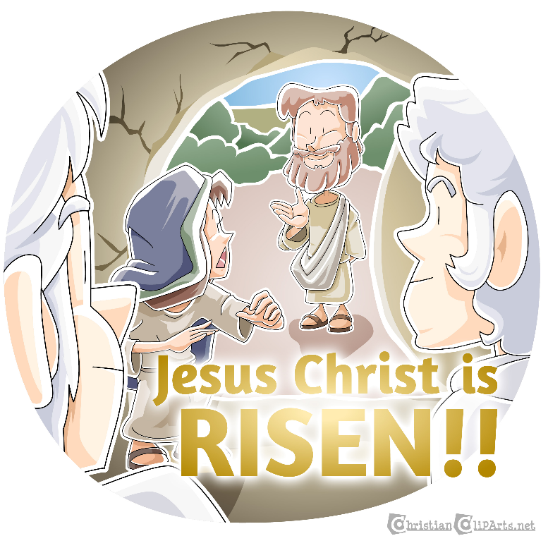
Children’s Message (Luke 24:1-12)
He is risen! The hope of Easter
Written by Kristin Schmidt for Ministry-To-Children.com
Main Objective: This is it! For the church, Easter and Christmas are the high holy days, sure to attract attention and attendance. Children hunt for plastic eggs and dress in fancy attire, but sometimes might not quite understand why the holiday is so significant. This message aims to remind kids and adults alike of the reasons why Easter is so important.
Law/Gospel Theme: The good news of the resurrection is the hope of new life that it brings. We all search for something to put our hope and faith into, but there is only one thing that will satisfy the desires of our hearts. Jesus is the central figure and focus of the entire Bible. The incarnation fulfills God’s promises to us and the death and resurrection complete that work. We rejoice in the resurrection because through it we have new life.
Optional Materials: Easter basket, Easter eggs (at least one empty), white cloth or linen, Easter items (bunny, candy, etc.)
Message: Note: All elements are open to adjustment. Cater to the needs and ages of your group
Come to deliver the message, carrying a basket of some sort filled with various Easter items.
“Happy Easter!!! (Speak rapidly and excitedly) Oh I just love Easter it’s so great and we have egg hunts and last year I found an egg that had a whole dollar in it and I really love those marshmallow Peeps did you know there’s a new flavor out now and especially I like the Reese’s eggs with extra peanut butter inside and I got a new dress to wear for church today and look I have a basket! Hang on…maybe I’d better slow down.
What is the best part of this holiday? Do you know why we celebrate Easter? (Pause for possible responses)
Well I have some items here in my Easter basket, and maybe they can help figure out the best elements of Easter…(hold up stuffed animal bunny/chick/etc) Oh, isn’t this guy cute?
You might have been seeing a lot of these things around lately…but I’m not sure if that is what we’re celebrating today. (Display eggs)
Well, we’ve been doing a lot of fun things with eggs. They sure are colorful. Maybe this one has some candy inside! (Open large empty egg)
Well, that’s disappointing; it’s empty! (Introduce candy) oooh chocolate! Surely that’s the best thing about Easter, right? Hmm…And hey, what’s this? It looks like a hankie. Why would someone put that in an Easter basket?
Well, here’s an interesting thing. A lot of the things that we see at Easter, like eggs and bunnies and chickens, go way back to people who celebrated springtime traditions. After long winters in the cold, people were excited to have warmer weather and sunshine. They thought things like eggs symbolized new life. In fact even the name Easter might come from “Eostre,” who was actually a pagan goddess. But she was the goddess of dawn (extra fun fact, that’s where the term “East” comes from, since the sun rises in the East!), which is when the sun rises. People often see the sunrise as a hopeful event, because it means a new day is coming.
Now, we celebrate Easter in the church as the time when a different Son rose… today is when we remember the resurrection of Jesus! He was put to death, even though He had done nothing wrong, because He was taking the punishment for our sins. He died and was put in a tomb with a huge stone over the entrance. On Sunday, when some of His friends went to the tomb, they found out it was empty! All that was left of Jesus was the linens they used to wrap up His body (hold up linens again).
Now, an empty Easter egg might be disappointing, but an empty tomb is amazing. An angel told the ladies who went to see Jesus that He had risen from the dead and was alive! Well, they were so excited they ran to tell His disciples, and they were talking so fast they could hardly be understood. Do you think we can get that excited about Jesus? Knowing that we have freedom from our sins and new life in Jesus is a lot more exciting than spring time or chicken eggs. We have hope that outlasts the weather, and new life that lasts forever. For us, this holiday is even better than Christmas. Not only was Jesus born, but He lived and died, and came back to life!
This was the culmination of God’s big rescue plan for us. He is so great. The news of Easter is so great. How can we help but share it? Let’s do that every day. Easter isn’t just a day or a season, it’s hope in the risen Son and life in Him!
Optional take home: Easter treat (egg, cross, lamb, etc.)
Prayer: Offer thanks that God has saved us, and joy in the hope we have in Him:
(Have kids repeat each line, if desired)
Dear God,
Thank you for saving us
Thank you for your love
We have the hope of Easter
Help us share that with others
Thank you for your son Jesus
In His name we pray, Amen
Bible Verses to Reference: (Lesson is found in all gospels)

Jesus Has Risen (Luke 24:1-12)
On the first day of the week, very early in the morning, the women took the spices they had prepared and went to the tomb. ² They found the stone rolled away from the tomb, ³ but when they entered, they did not find the body of the Lord Jesus. ⁴ While they were wondering about this, suddenly two men in clothes that gleamed like lightning stood beside them. ⁵ In their fright the women bowed down with their faces to the ground, but the men said to them, “Why do you look for the living among the dead? ⁶ He is not here; he has risen! Remember how he told you, while he was still with you in Galilee: ⁷ ‘The Son of Man must be delivered over to the hands of sinners, be crucified and on the third day be raised again.’ ” ⁸ Then they remembered his words.
⁹ When they came back from the tomb, they told all these things to the Eleven and to all the others. ¹⁰ It was Mary Magdalene, Joanna, Mary the mother of James, and the others with them who told this to the apostles. ¹¹ But they did not believe the women, because their words seemed to them like nonsense. ¹² Peter, however, got up and ran to the tomb. Bending over, he saw the strips of linen lying by themselves, and he went away, wondering to himself what had happened.
New International Version (NIV)
Holy Bible, New International Version®, NIV® Copyright ©1973, 1978, 1984, 2011 by Biblica, Inc.® Used by permission. All rights reserved worldwide.

Jesus Christ is Risen image from ChristianClipArts.Net – Used with permission.
To reference this lesson: https://ministry-to-children.com/easter-childrens-sermon/

Dear Reader,
I’m Tony Kummer, the founder of Ministry-To-Children.
I want to say Thank you!
- For serving in Children’s Ministry
- For telling kids about Jesus
- For choosing our material
Our entire team is honored that you’re using our material to tell kids about Jesus.
We are not a big publishing company – just a small website that God is using in a big way.
All resources from Ministry-To-Chidren.com are 100% free to copy and use in any ministry setting. Reposting online is welcome but requires an HTML link back to our website.
We never charge or ask for donations, but here’s how you can help our mission:
- Tell your friends to look for “Ministry to Children” on Google
- Sign-up for our email newsletter
- Add me (and our writers) to your personal prayer list.
I’d love to hear your feedback on this download. You can leave a comment on the website or email me directly Tony@ministry-to-children.com

