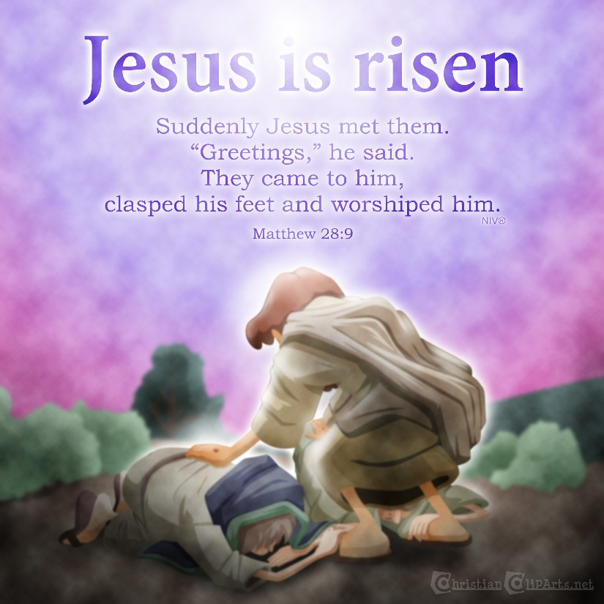
Hallelujah! He Has Risen!
Luke 23-24 Sunday School Lesson
Written by Kristin Schmidt for Ministry-To-Children.com
Easter, to Christians, should be the most important celebration of the year. After all, Easter reminds us of what Jesus did and how He rose from the dead. It reminds us that God fulfilled His promises and sent a savior. Sometimes we go through the motions and forget why Easter is so significant.
This lesson should help little ones understand the basics of God’s plan and prophetic conclusions, in order to help them appreciate the holiday beyond eggs and chocolate bunnies.
Lesson focus: Jesus died to take on our sins; His resurrection completed what God had intended from the beginning.
Passage: Luke 23:44-24:12 (ESV listed for reference)
Target Audience: Kindergarten-6th Grade (adaptable older or younger)
Materials Needed: Pieces of cloth; paper plates; paper; cups; present or gift bag
Lesson Opening: Use a couple of activities to open the lesson, starting with an outdoor game (if available facilities), and then enjoying a quieter illustration activity:
Game: are you alive? Have students line up on one end of a field, with one chosen participant standing or sitting at the other end of the field, with back to the others. Students quietly walk towards the “sleeper”, whispering or saying “are you alive?” At a chosen moment, the “it” will come to life and chase the others, trying to tag them before they run back to their side. If tagged, they join “it” in the chase. Otherwise, continue creeping toward “it”.
Taking on sins… have students sit in a circle, and hand each one a stack of post-it notes. Ask them to write down on the notes things that would be considered bad or sinful. As they write, have them place the post-its on themselves. Explain that we deserve punishments for the bad things we do. In the Old Testament, people had to select an animal to kill in place of their evil doings. Have the kids put their post-its on a stuffed animal. Should we destroy this animal to take care of our sins? Well, that seems strange…instead, take the post-its on yourself. Watch student reactions as you “wear” their transgression post-it notes. Explain that this was why Jesus came. And His death was not a random event. God had in mind all along how He would save people.

Sunday School Lesson for Easter
Show students a gift package, or a gift bag with a tag that says “do not open until Easter.” Ask them what they would think about getting a Christmas present that could not be opened until Easter. That seems sort of a lengthy wait! Explain that today we are celebrating the story of Easter. The beautiful thing about Easter is that it is the conclusion of the story that starts at Christmas. With Advent and Christmas, we celebrate how Jesus was born. But what was He born for? Ultimately, to take on our sins and die, so that we wouldn’t have to suffer. He did nothing wrong but was punished for what we did. With His resurrection, He had victory over sin and Satan. Invite students to look at some of the details of the story.
*note: for older students, you may look over some of the prophetic verses, and see how they were fulfilled in Christ. For younger kids, just mention how the things Jesus did had been predicted and talked about even before He was born.
Review the events leading up to the death of Jesus. Details may depend on previous lessons and how much you have already covered regarding the trials and crucifixion. Look at the verses depicting Christ’s final moments:
It was now about the sixth hour, and there was darkness over the whole land until the ninth hour, 45 while the sun's light failed. And the curtain of the temple was torn in two. 46 Then Jesus, calling out with a loud voice, said, “Father, into your hands I commit my spirit!” And having said this he breathed his last. 47 Now when the centurion saw what had taken place, he praised God, saying, “Certainly this man was innocent!” 48 And all the crowds that had assembled for this spectacle, when they saw what had taken place, returned home beating their breasts. 49 And all his acquaintances and the women who had followed him from Galilee stood at a distance watching these things. -Luke 23:44-49
Give students a small piece of cloth. Explain that, back before Jesus, when people made animal sacrifices, they had a special room in the temple where they could “meet” God. This special room could only be entered under very special circumstances, on a certain day by a certain person, and there was a curtain separating it from the other parts of the temple. When Jesus died, this curtain was torn apart, because Jesus made it so that we can always be in God’s presence, without any curtains hiding Him! Have students tear their cloth apart. Continue with the burial of Jesus:
Now there was a man named Joseph, from the Jewish town of Arimathea. He was a member of the council, a good and righteous man,⁵¹ who had not consented to their decision and action; and he was looking for the kingdom of God. ⁵² This man went to Pilate and asked for the body of Jesus. ⁵³ Then he took it down and wrapped it in a linen shroud and laid him in a tomb cut in stone, where no one had ever yet been laid. ⁵⁴ It was the day of Preparation, and the Sabbath was beginning. ⁵⁵ The women who had come with him from Galilee followed and saw the tomb and how his body was laid. ⁵⁶ Then they returned and prepared spices and ointments. On the Sabbath they rested according to the commandment. -Luke 23:50-56
Explain that people in Bible times often had reserved tombs where they could be buried. Someone (with a lot of money) had a family grave, and wanted to offer his tomb for the body of Jesus. He had special linens wrapped around the body and put a huge rock over the tomb. This man wanted to make sure no one tried to take or damage the body. He cared about Jesus and what would happen to Him. It was a Friday when Jesus was killed, and the next day was the Jewish Sabbath. This meant everyone had to rest and could not work. There were some women, though, who loved Jesus very much. They wanted to anoint His body with special oils. They went on Sunday (the third day) to do so, and found an interesting and intriguing surprise:
But on the first day of the week, at early dawn, they went to the tomb, taking the spices they had prepared. 2 And they found the stone rolled away from the tomb, 3 but when they went in they did not find the body of the Lord Jesus. 4 While they were perplexed about this, behold, two men stood by them in dazzling apparel. 5 And as they were frightened and bowed their faces to the ground, the men said to them, “Why do you seek the living among the dead? 6 He is not here, but has risen. Remember how he told you, while he was still in Galilee, 7 that the Son of Man must be delivered into the hands of sinful men and be crucified and on the third day rise.” 8 And they remembered his words,9 and returning from the tomb they told all these things to the eleven and to all the rest. 10 Now it was Mary Magdalene and Joanna and Mary the mother of James and the other women with them who told these things to the apostles, 11 but these words seemed to them an idle tale, and they did not believe them. 12 But Peter rose and ran to the tomb; stooping and looking in, he saw the linen cloths by themselves; and he went home marveling at what had happened.
-Luke 24:1-12
Even though prophets had foretold the Messiah, and Jesus Himself told people what would happen, the disciples and followers still didn’t quite expect or anticipate what they would find when they went to the grave. The three women who first encountered the empty tomb were so excited that they ran to tell the others, who didn’t even believe the story. It is significant that Peter, who had denied his Lord a few days before, was the first to inspect the tomb and marvel at what had happened.
When they saw the tomb and heard the angels, Mary, Joanna and Mary finally put the pieces together, and to an extent realized what was going on. Everything prior to this event was preparation. Everything after (the rest of the New Testament) happened in order to tell the world about Jesus. He is the central point of it all. If this is true of God’s word, it should be true in our lives. Our faith rests on the resurrection. Easter is about much more than candy and egg hunting. We don’t need to look for Jesus; He has risen! He’s just as alive in our midst and in our hearts today as He was on that first Easter morning. Let us rejoice! Let’s practice sharing that good news with others.
Craft options:
Make an empty tomb: have students use dark colors to decorate a paper plate, cut in half with an extra hole cut from the center. Provide large pom-poms or have students crunch paper into a ball to glue on as a “stone”, and attach a cross made from two popsicle sticks, as well. Include a verse caption and remind students of the beauty of the empty tomb!
Creative cross: provide cardstock or paper crosses. Allow students to color and decorate with glitter or tiny tissue pieces.
Jesus wins trophy: have students decorate cups or trophy-shaped items, and attach a caption of “Jesus wins the victory! He is risen!”
Close with prayer and thanks to God for sending Jesus to save us. Ask for joy in remaining to be “Easter people” and celebrating the work of Christ, and for courage in sharing God’s great love and gospel message with other people.
---
English Standard Version (ESV) The Holy Bible, English Standard Version. ESV® Text Edition: 2016. Copyright © 2001 by Crossway Bibles, a publishing ministry of Good News Publishers.
Jesus is Risen Illustration from ChristianClipArts.net – Used by permission.

I’m Tony Kummer, the founder of Ministry-To-Children.
I want to say Thank you!
- For serving in Children’s Ministry
- For telling kids about Jesus
- For choosing our material
Our entire team is honored that you’re using our material to tell kids about Jesus.
We are not a big publishing company – just a small website that God is using in a big way.
All resources from Ministry-To-Chidren.com are 100% free to copy and use in any ministry setting. Reposting online is welcome but requires an HTML link back to our website.
We never charge or ask for donations, but here’s how you can help our mission:
- Tell your friends to look for “Ministry to Children” on Google
- Sign-up for our email newsletter
- Add me (and our writers) to your personal prayer list.
I’d love to hear your feedback on this download. You can leave a comment on the website or email me directly Tony@ministry-to-children.com

