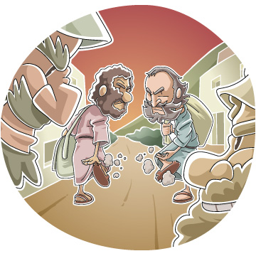
Jesus Sends Out Disciples Sunday School Lesson
Written by Tony Kummer for Ministry-To-Children.com
Scripture: Matthew 10:1-15
Passage Main Idea: Jesus included his disciples in his kingdom work.
Lesson Main Idea: We are also disciples of Jesus and have a part in his kingdom work.
Target Ages: This lesson is broadly elementary (age 6 – 12), please modify as needed for preschool or preteen students. It’s ideal for children’s church or Sunday School. Please leave us feedback on how you used this material work for your ministry.
Lesson Aim #1: The children will show a basic knowledge of this passage by …
- answering true or false quiz questions (see evaluation activity 1 – disciple trivia game)
- completing the 12 disciples worksheet as a group (see attached worksheet)
Lesson Aim #2: The children will begin to see their role in the work of the kingdom by …
- completing the “now & then” table able the disciple’s mission (evaluation activity 2a)
- brainstorming a list of 10 ways kids can share in kingdom work (evaluation activity 2b)
Materials Needed:
- Printed version of this lesson plan
- Attached worksheet on the 12 disciples
- Attached coloring pages – D is for Disciple
- Slips of paper and two baskets or cups (see Lesson introduction)
- Bible for the teacher and preferably every student, depending on teaching context.
Background Definitions: These are some key concepts behind this lesson. These concepts may be complicated for younger children but important for teachers to have in mind when they work through this lesson.
- A disciple is a student of Jesus: someone who follows his life example and tries to obey his teachings. When Jesus saves us from sin we become his disciples.
- The kingdom of heaven is everywhere that Jesus is at work rolling back sin, suffering, and sadness. Jesus died on the cross to forgive sins, but his kingdom is also fixing all the things that sin breaks. When he returns all sin and sadness will be finished forever.
- All followers of Jesus have a part in the work of the kingdom. We can both show and tell the good news about Jesus. We tell it when we share how Jesus came to save. We show it when we live right, love others, help suffering people, and work to fix injustice.

Lesson Introduction: What disciples do…
Write the following on small slips of paper and fold them over so the children can not see the content. As you begin the lesson, have the children take turns choosing a paper slip. They will read and the group will decide if it belongs in “Original Disciples” or “Disciples Living Now” bowls. For younger children, be prepared to guide the group to the right conclusions. Feel free to more specific task to this list that match your church’s ministry.
Raise the dead | Work at the hospital | Help a canned food drive
Cleans lepers | Remind your friends to wash their hands | Visit nursing homes
Cast out demons | Volunteer at homeless shelter | Help your elderly neighbors rake leaves
Stay away from Samaria | Tell a family member about Jesus | Invite a friend to church
Don’t travel with extra clothes or a backpack | Help someone learn English | Make friends with new neighbors
Don’t take extra silver or cooper | Become a scientist and fight cancer | Make friends who have special needs or disabilities
Stay with the first person that welcomes you to visit | Refuse drugs and alcohol – then help our friends to do the same. | Help others without expecting them to pay you back

This activity is meant to introduce the topic, not solve all the questions. Redirect tough questions gently, “Wow that’s a good question. Let’s look at today’s Bible story and see what we can learn.”
Transition (say) Some of those things seemed a little weird, let’s take a closer look in our Bibles to see if we can figure out how we can be a part of the work of Jesus.

Book Bible Content:
Have the children turn in their Bible to Matthew 10:1-15. If you are teaching a larger group, it may be easier to simply read it aloud from your Bible. Here are a few important talking points as you work through the passage. Scripture below from ESV for example.
(say) This is an exciting time for the disciples, because after spending so much time learning from Jesus, they finally got to help with some of his work. That’s what disciples means – a student of Jesus. Let’s read what happened:
And he called to him his twelve disciples and gave them authority over unclean spirits, to cast them out, and to heal every disease and every affliction. ² The names of the twelve apostles are these: first, Simon, who is called Peter, and Andrew his brother; James the son of Zebedee, and John his brother; ³ Philip and Bartholomew; Thomas and Matthew the tax collector; James the son of Alphaeus, and Thaddaeus;^{[a]4} Simon the Zealot,^{[b]} and Judas Iscariot, who betrayed him.
(say) Those are some cool names. Do any of you have friends who have those names? (allow time for response). That’s cool. Those original disciples are very famous now, but they were just regular people that Jesus choose to share in his work.
They didn’t have superpowers, it was the power of Jesus that made them special. Let’s see what kind of directions Jesus gave them when they started working.
These twelve Jesus sent out, instructing them, “Go nowhere among the Gentiles and enter no town of the Samaritans, ⁶ but go rather to the lost sheep of the house of Israel. ⁷ And proclaim as you go, saying, ‘The kingdom of heaven is at hand.’^{[c]} ⁸ Heal the sick, raise the dead, cleanse lepers,^{[d]} cast out demons. You received without paying; give without pay.
(say) Those do sound like some superpowers – can you imagine how cool it would be to heal sick people like Jesus did, make bad spirits go away, or even raise dead people back alive! (allow time for responses) He was letting them borrow his power to help people believe.
That power wasn’t just for showing off, Jesus also gave them an important message to explain why they could do miracles like that. The kingdom of Jesus was starting. All those miracles made sure people heard the message. They also showed what kind of kingdom Jesus was planning – one without sadness, where bad things became untrue.
This was something the Bible promised for hundreds of years. God was sending a special king who would fix all the bad things in the world. All the yucky stuff that sin got started was going to start going backwards. Jesus and his followers are how God was going to fix things. The stronger and bigger that kingdom became, the more and more sad things would become untrue.
You notice those powers were limited to the original disciples in this list – that’s one reason why they wrote down their names in the Bible. It was really the power of Jesus that he let the disciples borrow. This passage doesn’t say Jesus gave all Christians those powers, even though other passages say Jesus gave all his followers the work of telling the good news and helping others. Do you think God can still do amazing things if we pray and ask him? (allow for responses).
Let’s see what other directions Jesus gave his disciples.
⁹ Acquire no gold or silver or copper for your belts, ¹⁰ no bag for your journey, or two tunics^{[e]} or sandals or a staff, for the laborer deserves his food. ¹¹ And whatever town or village you enter, find out who is worthy in it and stay there until you depart. ¹² As you enter the house, greet it. ¹³ And if the house is worthy, let your peace come upon it, but if it is not worthy, let your peace return to you.
(say) That sounds like a real adventure and a little dangerous. Can you imagine going on a trip without having enough clothes, money, or even a place to stay? (allow time for responses)
Jesus wanted them to trust God in all their work. This was more proof that God was doing work through Jesus disciples. They were telling people good news about Jesus and they were doing good things to prove the message was true.
But what if the people don’t believe the disciples? Remember that lots of people didn’t believe in Jesus even with all the miracles. Let’s see what Jesus said:
And if anyone will not receive you or listen to your words, shake off the dust from your feet when you leave that house or town. ¹⁵ Truly, I say to you, it will be more bearable on the day of judgment for the land of Sodom and Gomorrah than for that town.
(say) That’s sad that people wouldn’t want to hear about such good news. Jesus was going to fix everything sin broke and was inviting everyone to join his new kingdom to share in the work. Why do you think some people wouldn’t want to hear the disciple’s message? (allow time for response).
There was one word in there we need to think about also – day of judgement. That means one day God will stop giving second chances. The people who didn’t want Jesus for king will not be allowed into his wonderful kingdom. Instead they will be sent far away and because they refused to come into that happy place. What do you think is the opposite of the Kingdom of Heaven? (allow brief time for responses – you may want to skip this question with younger kids)
The good news is nobody is forced out of God’s Kingdom, people get to pick sides. Jesus is very patient and loves all kinds of people. That’s why he sends his disciples to tell people the good news about his kingdom. We show that Jesus is King when we live right, love others, help suffering people, and work to fix injustice. This isn’t just for adults. Children have the same opportunities to make good choices and live according to the Gospel.

Lesson Aim #1 – Activities to teach understanding
Quiz Game: Depending on class size, divide into groups to play a quiz game on using the following question & answers based on the Bible passage. Use a dry erase board to mark the score as you go.
True or False
Jesus gave his disciple authority to turn water into wine. (FALSE) | Jesus gave all Christians the exact same powers he gave his original disciples. (FALSE)
The original disciples could raise the dead and heal sick people. (TRUE) | Leonardo, Michelangelo, Raphael, and Donatello were included in Jesus’ original disciples. (FALSE)
Kids are too young to help in the work of Jesus Kingdom (FALSE) | Jesus said the laborers deserve their food. (TRUE)
The disciples were supposed to stay with the people that welcomes them. (TRUE) | The disciples were told to shake the dust off their sandals if people didn’t listen. (TRUE)
Only certain people kinds of people are welcome into Jesus’ Kingdom. (FALSE) | Our part in the kingdom work is exactly like the work of the original disciples. (FALSE)
We can’t do miracles, so we can’t be a part of the kingdom work of Jesus. (FALSE) | We can ask God to do amazing things through prayer to show his power. (TRUE)

12 Disciples Worksheets: Pass out the attached worksheet and help the children follow the directions to review the names of the disciples.

Lesson Aim #2 – Activities that show children their role in the kingdom

Kingdom Work “Now & Then”
Using a whiteboard or large poster. Draw the following activities of the original disciples on the left for each action talk about how disciples now can serve the same mission. We show that Jesus is King when we live right, love others, help suffering people, and work to fix injustice. This activity has older children in mind, modify as needed for younger ages.
Original Disciples | What People Need | Disciples Now
Go to the villages and say, “the kingdom of heaven is at hand” | To know about Jesus | Tell friends about Jesus  Invite friends to church
Heal the sick, raise the dead, cleanse lepers, cast out demons | People need to get better when sick, sad, or enslaved to bad things | Help sick people  Become doctors or health workers,  Anything that shows love to people who are sad  Help people with addictions  Help people suffering injustice

Brainstorming: 10 Ways We Can Do Kingdom Work
Challenge the children to list ten specific ways they can share in the kingdom work of Jesus. Refer to the chart above for general ideas. Examples below can be suggested if kids come up blank – affirm good ideas or redirect them if they miss the point. The main idea is for kids to see they have important work in the kingdom of Jesus too!
- Invite my friend “Johnny” to church
- Tell my cousins about how Jesus loves them (even when they are bad)
- Do extra chores when my mom is sick
- Make friends with the new girl at school who can’t speak English
- Pray for my neighbors who use drugs
- Do well in school so I can become a doctor
- Ask my friends to stop making fun of the disabled boy at lunch
- Save part of my allowance for the food relief offering
- Hug my grandma when she is sad
- Memorize my Bible verses so I can be ready to share Jesus’ words with others

More Sunday School Activities
If you need to extend this lesson, we suggest some of the following activities and resources.
D is for Disciple Coloring Page: We’ve included two versions of this coloring page for kids to decorate before or after class.
Shaking Dust from Your Feet Coloring Page: We’ve included this coloring page as a bonus option from ChristianClipArts.Net. Inspired by Acts 13:50-52.
Kids Extras from LifeWay: They list several age appropriate learning games and crafts for this Bible passage.
Video - God’s Story Peter Tells About Jesus: Show this video clip about Peter from the book of Acts. He does exactly what Jesus says to do here in Matthew. He heals the sick and tells them about Jesus.
Video - What’s a Disciple Do: Fun kids question and answer session from Crossroads Kids Club.
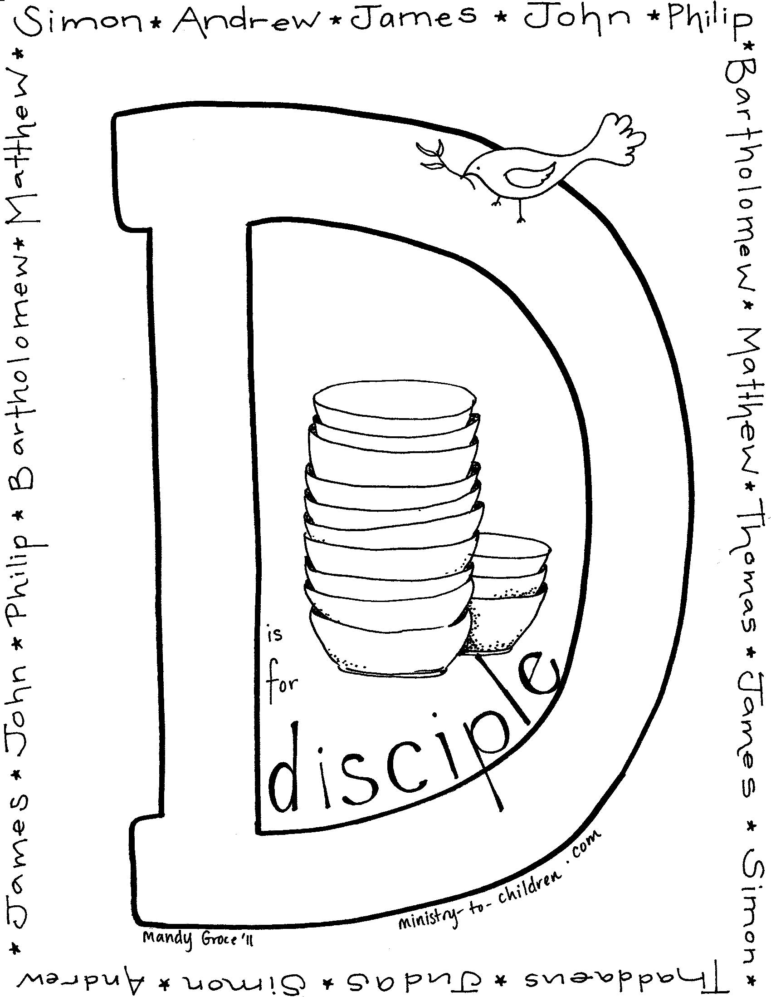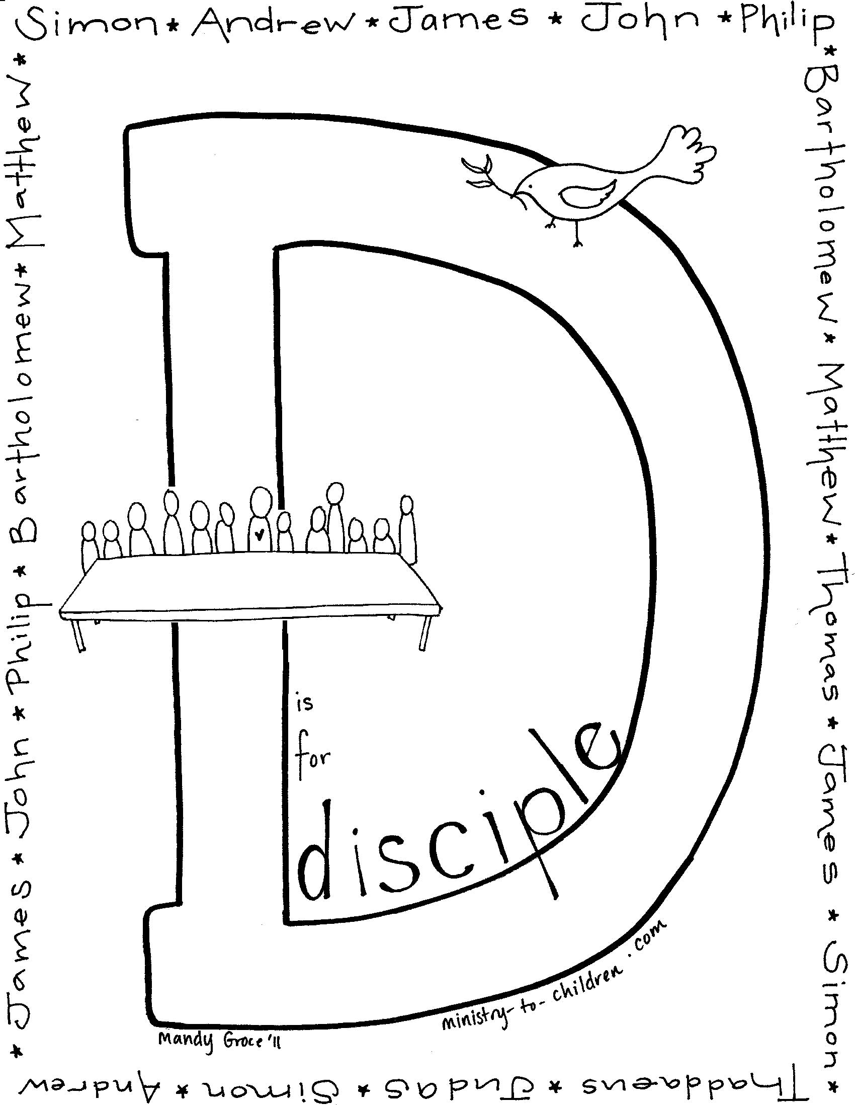
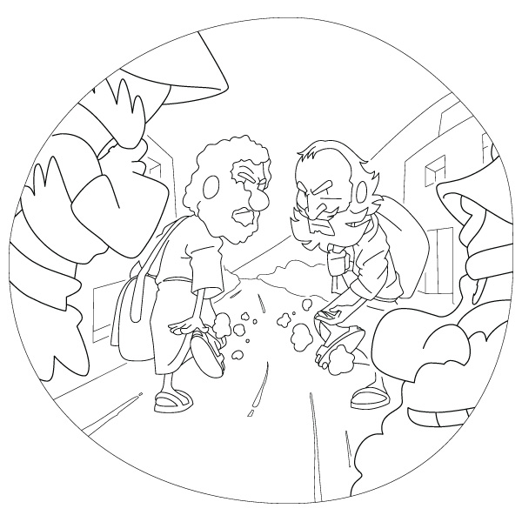

Matthew 10:14 ESV
And if anyone will not receive you or listen to your words, shake off the dust from your feet when you leave that house or town.
http://www.christiancliparts.net/viewillust.php?id=i13038bw

Matthew 10:1-15 English Standard Version (ESV)
The Twelve Apostles
10 And he called to him his twelve disciples and gave them authority over unclean spirits, to cast them out, and to heal every disease and every affliction. ² The names of the twelve apostles are these: first, Simon, who is called Peter, and Andrew his brother; James the son of Zebedee, and John his brother; ³ Philip and Bartholomew; Thomas and Matthew the tax collector; James the son of Alphaeus, and Thaddaeus;^{[a]4} Simon the Zealot,^{[b]} and Judas Iscariot, who betrayed him.
Jesus Sends Out the Twelve Apostles
⁵ These twelve Jesus sent out, instructing them, “Go nowhere among the Gentiles and enter no town of the Samaritans, ⁶ but go rather to the lost sheep of the house of Israel. ⁷ And proclaim as you go, saying, ‘The kingdom of heaven is at hand.’^{[c]} ⁸ Heal the sick, raise the dead, cleanse lepers,^{[d]} cast out demons. You received without paying; give without pay. ⁹ Acquire no gold or silver or copper for your belts, ¹⁰ no bag for your journey, or two tunics^{[e]} or sandals or a staff, for the laborer deserves his food. ¹¹ And whatever town or village you enter, find out who is worthy in it and stay there until you depart. ¹² As you enter the house, greet it. ¹³ And if the house is worthy, let your peace come upon it, but if it is not worthy, let your peace return to you. ¹⁴ And if anyone will not receive you or listen to your words, shake off the dust from your feet when you leave that house or town. ¹⁵ Truly, I say to you, it will be more bearable on the day of judgment for the land of Sodom and Gomorrah than for that town.
Footnotes:
- Matthew 10:3 Some manuscripts Lebbaeus, or Lebbaeus called Thaddaeus
- Matthew 10:4 Greek kananaios, meaning zealot
- Matthew 10:7 Or The kingdom of heaven has come near
- Matthew 10:8 Leprosy was a term for several skin diseases; see Leviticus 13
- Matthew 10:10 Greek chiton, a long garment worn under the cloak next to the skin
English Standard Version (ESV)
The Holy Bible, English Standard Version. ESV® Text Edition: 2016. Copyright © 2001 by Crossway Bibles, a publishing ministry of Good News Publishers.

Matthew 10:1-15 New International Reader's Version (NIRV)
Jesus Sends Out the Twelve Disciples
10 Jesus called for his 12 disciples to come to him. He gave them authority to drive out evil spirits and to heal every illness and sickness.
² Here are the names of the 12 apostles.
First there were Simon Peter and his brother Andrew.
Then came James, son of Zebedee, and his brother John.
³ Next were Philip and Bartholomew,
and also Thomas and Matthew the tax collector.
Two more were James, son of Alphaeus, and Thaddaeus.
⁴ The last were Simon the Zealot and Judas Iscariot. Judas was the one who was later going to hand Jesus over to his enemies.
⁵ Jesus sent these 12 out with the following orders. “Do not go among the Gentiles,” he said. “Do not enter any town of the Samaritans. ⁶ Instead, go to the people of Israel. They are like sheep that have become lost. ⁷ As you go, preach this message, ‘The kingdom of heaven has come near.’ ⁸ Heal those who are sick. Bring those who are dead back to life. Make those who have skin diseases ‘clean’ again. Drive out demons. You have received freely, so give freely.
⁹ “Do not get any gold, silver or copper to take with you in your belts. ¹⁰ Do not take a bag for the journey. Do not take extra clothes or sandals or walking sticks. A worker should be given what he needs. ¹¹ When you enter a town or village, look for someone who is willing to welcome you. Stay at their house until you leave. ¹² As you enter the home, greet those who live there. ¹³ If that home welcomes you, give it your blessing of peace. If it does not, don’t bless it. ¹⁴ Some people may not welcome you or listen to your words. If they don’t, leave that home or town, and shake the dust off your feet. ¹⁵ What I’m about to tell you is true. On judgment day it will be easier for Sodom and Gomorrah than for that town.
New International Reader's Version (NIRV)
Copyright © 1995, 1996, 1998, 2014 by Biblica, Inc.®. Used by permission. All rights reserved worldwide.

Matthew 10:1-15 International Children’s Bible (ICB)
Jesus Sends Out His Apostles
10 Jesus called his 12 followers together. He gave them power to drive out evil spirits and to heal every kind of disease and sickness. ² These are the names of the 12 apostles: Simon (also called Peter) and his brother Andrew; James son of Zebedee, and his brother John; ³ Philip and Bartholomew; Thomas and Matthew, the tax collector; James son of Alphaeus, and Thaddaeus; ⁴ Simon the Zealot and Judas Iscariot. Judas is the one who turned against Jesus.
⁵ These 12 men he sent out with the following order: “Don’t go to the non-Jewish people. And don’t go into any town where the Samaritans live. ⁶ But go to the people of Israel. They are like sheep that are lost.⁷ When you go, preach this: ‘The kingdom of heaven is coming soon.’⁸ Heal the sick. Give dead people life again. Heal those who have harmful skin diseases. Force demons to leave people. I give you these powers freely. So help other people freely. ⁹ Don’t carry any money with you—gold or silver or copper. ¹⁰ Don’t carry a bag. Take for your trip only the clothes and sandals you are wearing. Don’t take a walking stick. A worker should be given the things he needs.
¹¹ “When you enter a city or town, find some worthy person there and stay in his home until you leave. ¹² When you enter that home, say, ‘Peace be with you.’ ¹³ If the people there welcome you, let your peace stay there. But if they don’t welcome you, take back the peace you wished for them. ¹⁴ And if a home or town refuses to welcome you or listen to you, then leave that place. Shake its dust off your feet.^{[a]} ¹⁵ I tell you the truth. On the Judgment Day it will be worse for that town than for the towns of Sodom and Gomorrah.^{[b]}
Footnotes:
- 10:14 Shake . . . feet. A warning. It showed that they were finished talking to these people.
- 10:15 Sodom and Gomorrah Two cities that God destroyed because the people were so evil.
International Children’s Bible (ICB)
The Holy Bible, International Children’s Bible® Copyright© 1986, 1988, 1999, 2015 by Tommy Nelson™, a division of Thomas Nelson. Used by permission.

