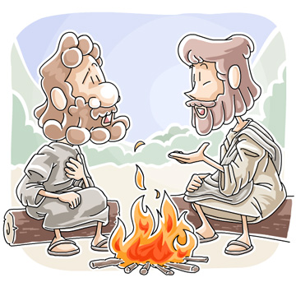
Children’s Message (John 21:1-19)
Jesus Forgives Peter / Miraculous Catch
Fish Fry Breakfast and Forgiving Friends
Written by Kristin Schmidt
Main Objective: Discussing and exploring the post-Easter stories of Christ’s appearances is a great way to continue the joy and message of the Resurrection. This story deals with Peter, who messed up when the moment was tight, but was still used by God in amazing ways. This message reminds kids that God can and does use anyone, and that we have important jobs to carry out His work, if we are willing.
Law/Gospel Theme: Forgiveness is an essential part of the Gospel message, and an important concept to teach kids of all ages. Culture often glorifies justice or vengeance, but God’s word has something different to say. This story has a happy reunion of friends after Easter, but it also reminds us of the importance of grace. God has taken care of our sins and covered the bad things we do, so our reaction should be eagerness to serve Him.
Optional Materials: Books or items that have to do with the number three (Three Little Pigs, Goldilocks and the Three Bears, triangles, tricycles, etc.); possibly fish/fishing pole or net.
Message: Note: All elements are open to adjustment. Cater to the needs and ages of your group Greet children and introduce the “threes” theme of the message.
Good morning!
I have a few items here that have something in common. Do you know what story this is? (Hold book) That’s right; it’s the Three Little Pigs! How about this one? Yes, it’s Goldilocks and the Three Bears. Look at these pictures… yes, this is a triangle. That’s a triceratops!
Do you know what these things have alike? They all have to do with the number three. And you know, in the story today, there’s something that happens three times.
Now, I have a question… (Address individual) , did you get in trouble this morning? (Allow response, hopefully a no!) Are you sure you didn’t? Are you positive you haven’t been in trouble lately?? Hmmm, well all right….
(Address different child) Who is your best friend? Who do you enjoy playing with? (Ask the same question again) Who is it that you play with? Are you sure?
See, our Gospel lesson today has to do with someone who answered a question three times. We have been talking about some stories where we saw Jesus meeting His friends after He came back to life. He did this a few times. During one of those times, He met some of the disciples as they were out fishing. (Hold up fishing gear, if using). Remember how some of the disciples were fishermen?
Jesus helped them one morning when they were having trouble with their fishing work. He helped them catch a whole bunch of fish! Then they came to the beach, and Jesus cooked some of the fish. Do you have fish for breakfast? Maybe not….but these guys did. And then Jesus started talking to Peter.
Do you remember the disciple Peter? The night that Jesus died, Peter pretended that he didn’t even know who Jesus was. In fact, he lied three times and said he didn’t know Jesus! So here on the beach, he might have still been feeling sad about that. But Jesus gave him a second chance. He asked Peter if he loved Jesus, and told him to “feed my sheep.”
That was how Jesus told Peter to take care of God’s people. Peter told the Lord that he loved Him, but Jesus asked two more times…three times He asked Peter if He loved Him, and told him to take care of the people.
So Peter knew that he was forgiven, and that he had a special and important job to do. And do you know what? The same applies to us! We know we have been forgiven by God. Nothing we can do will erase His love for us.
Our job is to love Him in return, to accept His grace, and to serve Him by taking care of His people. This is an essential task for us, and something that most certainly pleases God. Let’s look for ways we can celebrate that opportunity this week!
Prayer: Offer thanks that God forgives us, and help in serving Him:
(Have kids repeat each line, if desired)
Dear God,
Thank you for your forgiveness
Thank you for the Bible and its truth
Help us to follow you and serve you
Thank you for your love
Thank you for Jesus!
In His name, amen

John 21:1-19 (ESV) Jesus Appears to Seven Disciples
21 After this Jesus revealed himself again to the disciples by the Sea of Tiberias, and he revealed himself in this way. ² Simon Peter, Thomas (called the Twin), Nathanael of Cana in Galilee, the sons of Zebedee, and two others of his disciples were together. ³ Simon Peter said to them, “I am going fishing.” They said to him, “We will go with you.” They went out and got into the boat, but that night they caught nothing.
⁴ Just as day was breaking, Jesus stood on the shore; yet the disciples did not know that it was Jesus. ⁵ Jesus said to them, “Children, do you have any fish?” They answered him, “No.” ⁶ He said to them, “Cast the net on the right side of the boat, and you will find some.” So they cast it, and now they were not able to haul it in, because of the quantity of fish.⁷ That disciple whom Jesus loved therefore said to Peter, “It is the Lord!” When Simon Peter heard that it was the Lord, he put on his outer garment, for he was stripped for work, and threw himself into the sea.⁸ The other disciples came in the boat, dragging the net full of fish, for they were not far from the land, but about a hundred yards off.
⁹ When they got out on land, they saw a charcoal fire in place, with fish laid out on it, and bread. ¹⁰ Jesus said to them, “Bring some of the fish that you have just caught.” ¹¹ So Simon Peter went aboard and hauled the net ashore, full of large fish, 153 of them. And although there were so many, the net was not torn. ¹² Jesus said to them, “Come and have breakfast.” Now none of the disciples dared ask him, “Who are you?” They knew it was the Lord. ¹³ Jesus came and took the bread and gave it to them, and so with the fish. ¹⁴ This was now the third time that Jesus was revealed to the disciples after he was raised from the dead.
Jesus and Peter
¹⁵ When they had finished breakfast, Jesus said to Simon Peter, “Simon, son of John, do you love me more than these?” He said to him, “Yes, Lord; you know that I love you.” He said to him, “Feed my lambs.” ¹⁶ He said to him a second time, “Simon, son of John, do you love me?” He said to him, “Yes, Lord; you know that I love you.” He said to him, “Tend my sheep.” ¹⁷ He said to him the third time, “Simon, son of John, do you love me?” Peter was grieved because he said to him the third time, “Do you love me?” and he said to him, “Lord, you know everything; you know that I love you.” Jesus said to him, “Feed my sheep. ¹⁸ Truly, truly, I say to you, when you were young, you used to dress yourself and walk wherever you wanted, but when you are old, you will stretch out your hands, and another will dress you and carry you where you do not want to go.” ¹⁹ (This he said to show by what kind of death he was to glorify God.) And after saying this he said to him, “Follow me.”
English Standard Version (ESV)
The Holy Bible, English Standard Version. ESV® Text Edition: 2016. Copyright © 2001 by Crossway Bibles, a publishing ministry of Good News Publishers.
Jesus Reinstates Peter image from Christian Clip Arts – Used with permission.

We hope you enjoy this free resource.
Everything from Ministry-To-Chidren.com is 100% free to copy & use in ministry.

I’m Tony Kummer - I started this website in 2007, but God is using it beyond my imagination. We have a simple mission.
Help people tell kids about Jesus!
Our team is honored that you choose our material. Thank you for …
- serving where God has placed you.
- telling children about Jesus.
- allowing us to be a part of your mission.

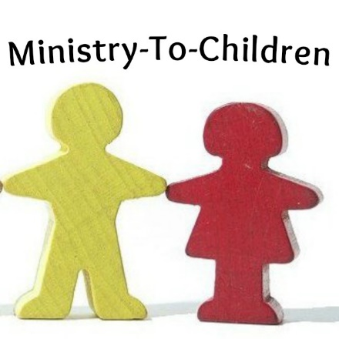
We don’t ask for money, but we do need your help.
Please consider the following:
- Comment on the website to encourage our authors.
- Link to us from your blog or church website.
- Share our posts on Pinterest or Facebook.
- Tell a friend to google “Ministry to Children.”
- Add me (and our team) to your personal prayer list.

I’d love to hear your feedback on this download. Tony@ministry-to-children.com
May God bless you and continue to bless your ministry!

