Lesson 19
FORGIVEN TO HAVE A FUTURE

PRAISE (15mins)
Jesus is my Saviour

INTRODUCTION (6mins)
GAME – Simon Says Three Times
We all know Simon Says and so we are going to play that quickly. Only ….. there is a twist to today’s game. Whatever Simon Says, you have to do it three times. If Simon says jump, you jump three times. If Simon says clap, clap three times. If Simon asks a question, students answer three times.
Why did you have to do everything three times? Well, the number 3 plays a big part in today’s Bible Time. Three things that Peter said and three things that Jesus said show us something very important in our Christian lives. Do you know what they were? They said …………. NAH, I not going to tell you now. We’ll find out shortly ……..

DVD (4mins)
Let’s look quickly at the behaviour of Johnny Test
https://www.youtube.com/watch?v=4JSRd6AfXO4 ------------ show till 2.30
What bad behaviour! Being rude and disrespectful, being selfish and destructive, being irritating and fighting with others. He’s making a lot of trouble!
But before we just look at Johnny’s behaviour, let’s ask ourselves a question as well. Have we maybe ever been rude and disrespectful. Have we ever fought with others and been selfish? Have we ever messed by and done wrong things?
I know that we all have done wrong. Some things we are ashamed that we did it. Others we wished that we had never done them. We all have failed God in our behaviour somehow.
Because we have failed and messed up, doesn’t that mean that God is finished with us? Does it mean that our lives can never be used by God?
Let’s go to Bible Time now and the three things Peter and Jesus said and see how God answers these questions we have asked.

BIBLE TIME (8mins)
PowerPoint
Peter’s Call, Failure and Restoration - Luke 5:1-11, Gospel account of Jesus, John 13:37-38, Luke 22:54-62, John 21:1-17, Acts
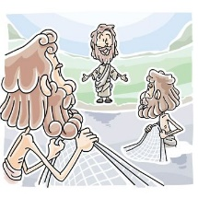
We all know who Peter was. He was a simple fisherman whose life was changed when Jesus came and told Peter to leave his fishing and follow Him. “I will make you a fisher of men,” Jesus told Peter. The next 3 years were crazy! As Peter followed Jesus, he saw miracles and healings. He saw Jesus walk on water and calm a storm. He saw Jesus raise the dead. Peter saw Jesus pray and talk to His Father. He also heard the wonderful teaching of Jesus about the Father and the Kingdom of God. What an amazing time!
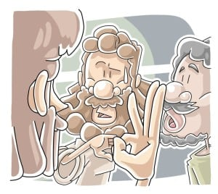
Then the bombshell came! Jesus was telling Peter and the other disciples that He was soon going to be killed and buried and that He would rise again to life on the third day. This made no sense at all. And so Peter jumped in and said that he will never let this happen to Jesus. Jesus told Peter to back off because he would still deny that he knew Jesus 3 times.
Here are the first of the 3 things that were said. Peter said these 3 things. After Jesus was arrested and taken to the High Priest for the trial, Peter was waiting outside with the servants around a fire. Three times people asked Peter if he was with Jesus. Three times Peter denied that he even knew the Lord. When the cock crowed, Peter remembered the words of Jesus. He was shattered as he realised that he had messed up no badly.
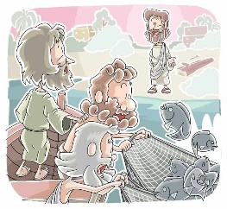
Fast forward now. Jesus was crucified, He died and was buried in the tomb. Just like Jesus said, on the third day Jesus rose to life again and had already visited Peter and the disciples a few times.
Peter still lived with his failure. He had messed up big time and felt so guilty and that he had ruined all that Jesus was teaching him. Peter and some disciples had gone back to fishing and early one morning they were pulling in their nets. Nothing! They had caught nothing! Peter couldn’t even fish anymore!
Then someone called to them from the land asking what they had caught. “Nothing,” Peter replied. The person on the beach then told them to drop the nets on the other side of the boat and they would catch fish. Strange but Peter and the others did it. The nets were so full of fish that they couldn’t cope with it. 153 large fish!
“It is Jesus,” cried John. Peter jumped into the water and went to Jesus while the others towed the huge catch of fish to shore. There Jesus already had a fire going with fish cooking on the fire.
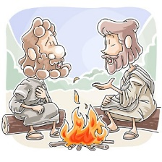
Here as they ate with Jesus, the next 3 things were said. This time Jesus spoke the words. Jesus told Peter to “Feed His lambs,” “Take care of His sheep,” and “Feed His sheep.” The lambs and the sheep that Jesus spoke about are the people who are Christians and in the Church. Jesus wanted Peter to take care of His people.
But Peter had failed Jesus! He had messed up so much! How could Jesus still have a plan to use him? This is our message today. Even though we mess up and fail, God still has a plan in which He can use us and we can do great things for God.
Peter went on and became a leader in the church. God used him in mighty miracles and to tell many, many people about the Lord. God used Peter to strengthen the church and to guide them through the rough times. Peter messed up but it wasn’t the end. Totally forgiven, Peter was able to be used by God in special ways.
You have done wrong things and so have I. that doesn’t destroy our lives. We are sorry for it and God forgives us but God’s plan to use us goes on. Peter didn’t stay guilty but he accepted the love and forgiveness of Jesus and he let God use him.
What will you do?

BRAINSTORMING (6mins)
Whiteboard
[Write down the thoughts of the children as they share]
We are going stop and dream together here a bit. I want you to think for a moment. You know your life and what is happening in your world. Knowing this, what do you think that God would like to do through you? How would God like to use you? What would you like to do for God?
Wow! Look at all these dreams of what God may do through us. There are still hundreds of other possibilities that we haven’t even thought of yet. All of these thigs ARE possible. God can do anything through you. He doesn’t need you to be strong and have all knowledge and very talented. God just needs to be available and obedient and He can do through you many wonderful things.
People forgiven, sicknesses healed, hurting hearts mended, empty people finding hope, angry people finding peace, relationships fixed, freed from self-hurting behavior …….. and on and on we can go. God can and He WANTS TO use you to do His work in people’s lives.
Who here says “I want God to use my life like this!” Me as well! In a moment we will pray and we are going to give our lives to Jesus so that He can use us.

APPLICATION (8mins)
Object Lesson – a rope and some padding
[Choose a child to stand with you and be the illustration]
We all have the same possibilities of doing good things and being used by God. We all want this and we want our lives to count and make a difference for the Lord. We are going forward to get to place where God is going to use us. But also like everyone else, we have bad experiences in life. We do wrong things, we feel terrible and things aren’t going smooth.
[Using the padding around the ankle, tie the child’s ankle to something that they cannot move]
What happens to us when we mess up? The guilt of the mistake we made or the wrong we did, attaches us to that event. We become linked to our mistake because we feel we are terrible and not good enough. This is where so many people sit. They never do things for God because they are tied to a past mistake and now they’re not good enough.
No matter how much they want to move forward, as long as they are tied to a past mistake, they cannot move forward.
[Start untying the child as you speak for that they can continue their walk]
Jesus didn’t want Peter stuck to his failure. Jesus forgave Peter and got him moving forward to a place where God was going to use Peter mightily. In the same way God wants to free us.
Those dreams written on the board are great. God wants to use you even more than you want it. He has special plans prepared for you. But you will never get there if you are held to a past mistake or happening. Forgive people and forgive yourself. Believe what God says about you instead of believing the devil’s lies about you. Be obedient to the Holy Spirit instead of making excuses.
Let’s forget our past mistakes because they are forgiven. Let’s break out of the guilt that traps us so that we don’t move. Let’s be available to God and ready to allow Him to use us to touch the lives of many people.
[Be prepared as the Spirit leads you to pray over forgiveness, lies and empowerment for service]

EXTRA TIME (10mins)
Be prepared with an activity for any extra time you may have – fun and relational, connecting with the children

