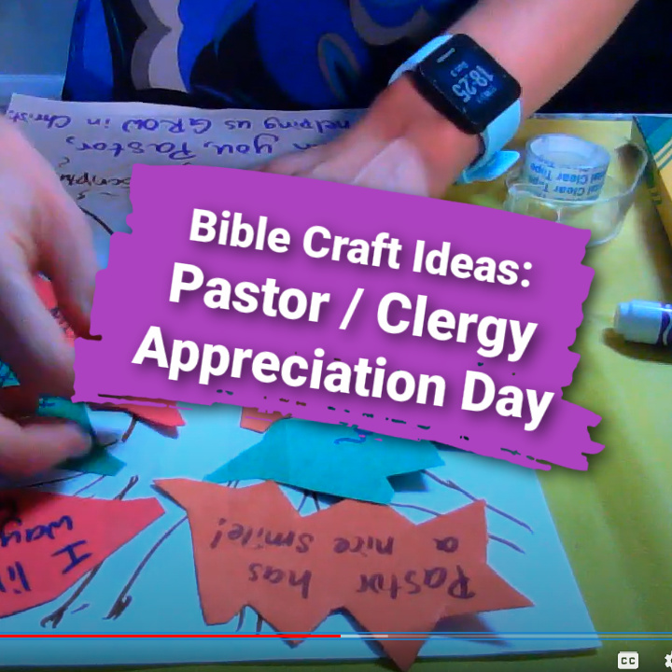Thank Your Pastors!  
Bible Crafts for Pastor Appreciation Day

Pastors do so much for us, and we hardly know the challenges and stresses they face daily. Those in ministry guide us in understanding God’s Word and in a sense speak for Him in they spiritually lead their congregations. It is important to support our pastors with prayer, encouragement, and words of appreciation. If you are looking for a creative way to express gratitude to pastors, try a variation on one of these simple but heart felt card options.

**Bible Verses or Craft Captions to Consider… (Hebrews 5:1-10 )**

*So also Christ did not exalt himself to be made a high priest, but was appointed by him who said to him,*

*“You are my Son,*

*today I have begotten you” -Hebrews 5:5*

*Thank you for helping us grow in Christ!*

*You “shepherd” our flock, Pastor!*

*Thank you for touching our hearts!*

*You “root us” in God’s word!*

*Pastors guide and lead in God’s ways. Thank you!*

**More Children’s Ministry Ideas:**

* Watch the video of this [children’s sermon](https://youtu.be/QSNkBzp8DVI) and related [Bible craft ideas](https://youtu.be/Hxx9dXm8tzI)
* Download our free [pastor appreciation coloring pages](https://ministry-to-children.com/pastor-appreciation-coloring-page/)
* Compare another [children’s sermon lesson on Pastor Appreciation](https://ministry-to-children.com/pastor-appreciation-day/)

Craft one: “Hands and Hearts Card”

**You will need:**

* Yarn, pipe cleaner, or ribbon
* Cross or popsicle sticks (optional)
* Scissors
* Glue or tape
* Markers and/or crayons
* Construction paper or cardstock

**Procedure:**

1. Choose one or several pastor “themes” to create your card: a shepherd’s staff, cross, handprint, heart, or all of the above could work!
2. Trace a hand onto the paper, cut one out of paper, or paint a hand print stamp onto paper.
3. Add a cross shape or popsicle sticks in the shape of a cross.
4. Place a heart in or near the hand. Twist pipe cleaners or string into the shape of a shepherd’s staff, if desired.
5. Add captions and verses. Attach string if you wish to hang the card later.

Craft Two: “Growing in Christ Card”

**You will need:**

* Markers/crayons
* Cardstock/paper
* Glue or tape
* Scissors
* Additional decorations (glitter, sequins, etc.)
* A picture containing text, envelope

  Description automatically generatedCaptions/verses

**Procedure:**

1. Draw a tree as the base of your card, using cut paper or drawn lines.
2. Cut leaf shapes out of several pieces of foam or paper. Have students and teachers sign notes and words of encouragement on each leaf.
3. Attach extra decorations and stickers as preferred.
4. Add verses and captions, and present the card to your pastor.

* Alternate option: make a large poster or bulletin board with this same theme.



Thank you for downloading these free materials. Our team is grateful for your trust and pray that God will bless your ministry.

This resource was prepared by [Kristin Schmidt](https://ministry-to-children.com/author/kristins/) (pictured right). She serves at the Epiphany Lutheran Church in Castle Rock, CO. She has shared her teaching gifts through *Ministry-To-Children* since 2014 and now serves as our lead curriculum writer.

Every week she writes new [Sunday School lessons](https://sundayschool.works/sunday-school-lessons/), [Bible crafts](https://ministry-to-children.com/curriculum/activities/crafts/), and [children’s sermons](https://ministry-to-children.com/curriculum/lesson-plans/childrens-sermons/).

Kristin has a professional background in elementary and pre-school education. A graduate of Biola University, she holds a Master of Education and will receive the Master of Theology degree from Concordia University, Irvine, California, in May 2020. Kristin grew up in southern California and lived the past 10 years in Georgia. She is a long-distance runner and voracious reader.

My name is Tony Kummer (pictured below). I started Ministry-To-Chidlren.com in 2007 as a free resource for anyone sharing Jesus with kids. It is my personal honor to share these resources with churches around the world.

[Reader donations](https://ministry-to-children.com/support-this-ministry/) and your support at [The Sunday School Store](https://sundayschool.store/) fund these free materials. Please keep us in mind when you are choosing your next children’s ministry curriculum.

If you enjoy our material, be sure to [sign-up for my free email newsletter](https://sundayschool.works/subscribe/) called “Sunday School Works!” Every Tuesday, I send the latest new lessons, crafts, and coloring pages in print-friendly format to make your lesson planning easy.

May God continue to bless your ministry!